

**Big Data for Managers & Analytics**

**Submitted To:**

Prof. Amarnath Mitra

**Report on** **Project on** **Database Management using MySQL**

**Topic:** Indian Banking Transaction System

**Submitted by: Sanyuktaa Nath (064045)**

1. **Project 1c: Database & Tables with Dummy Data**
2. **Database :**

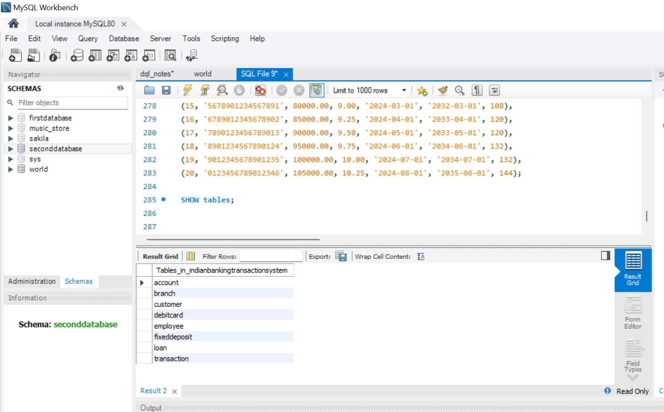

1. **Tables With Dummy Data**

* **Account Table :**

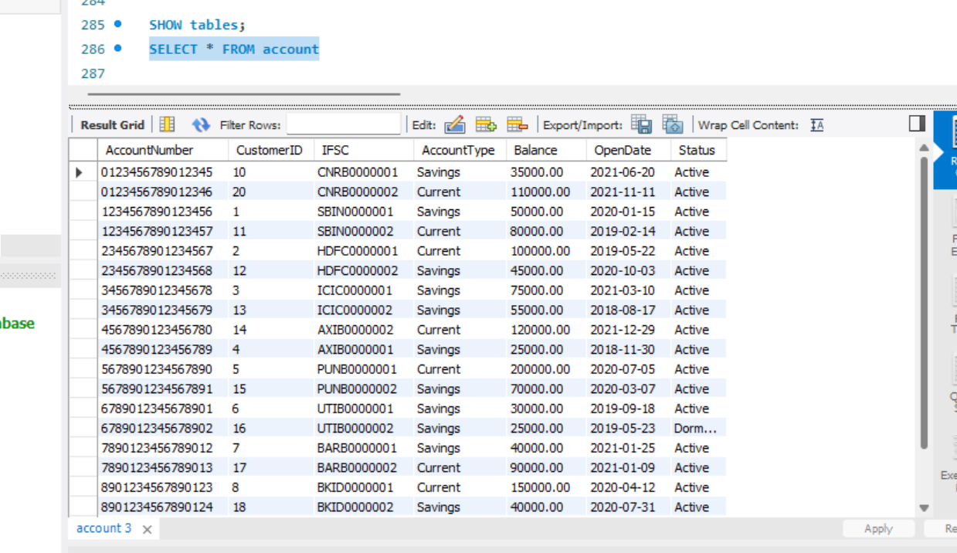

* **Branch Table :**

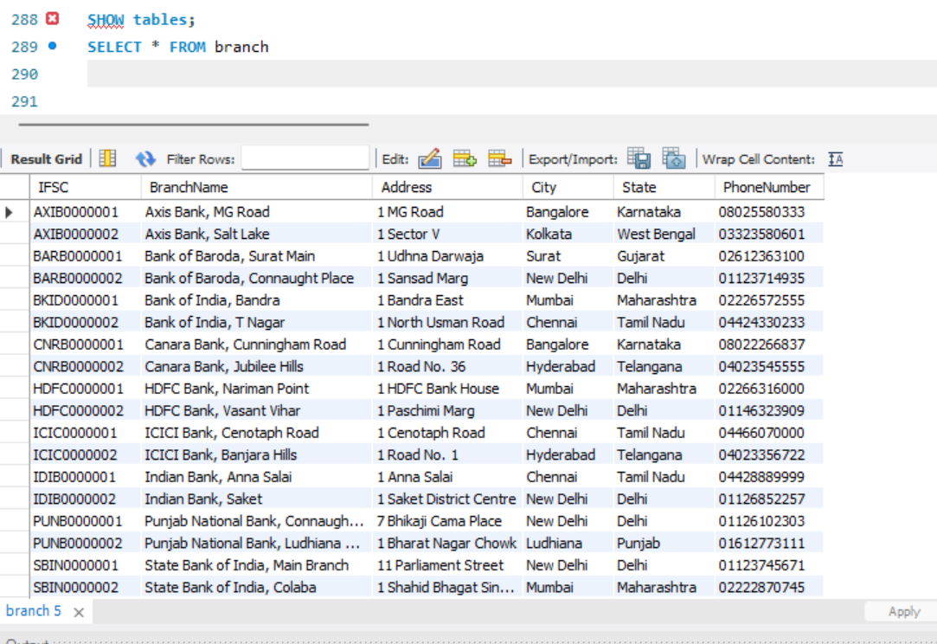

* **Customer Table:**

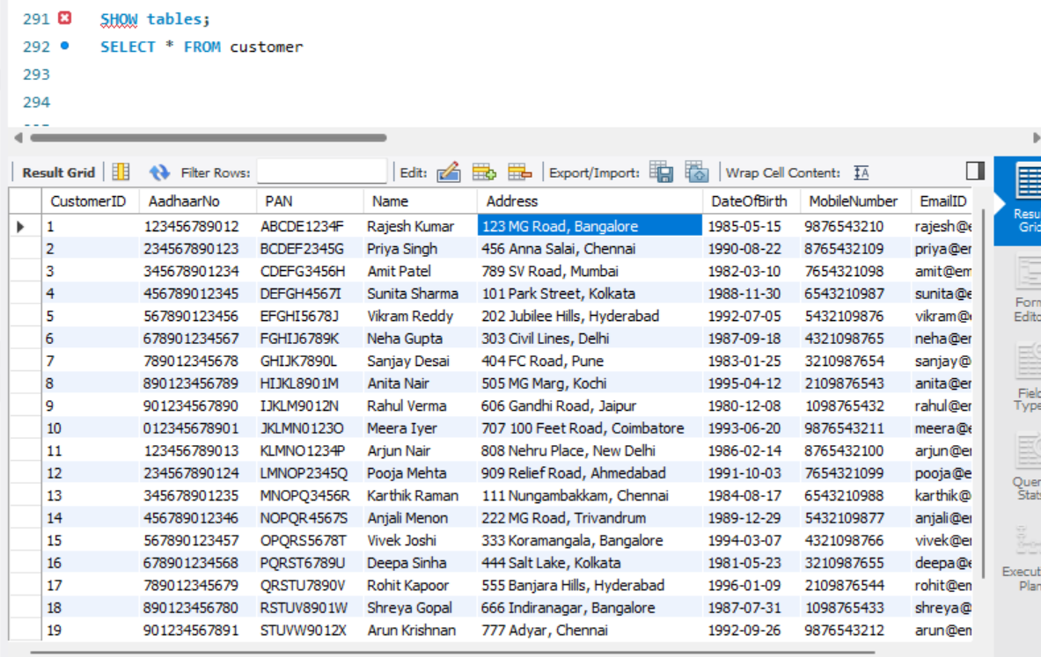

* **Debit card Table:**

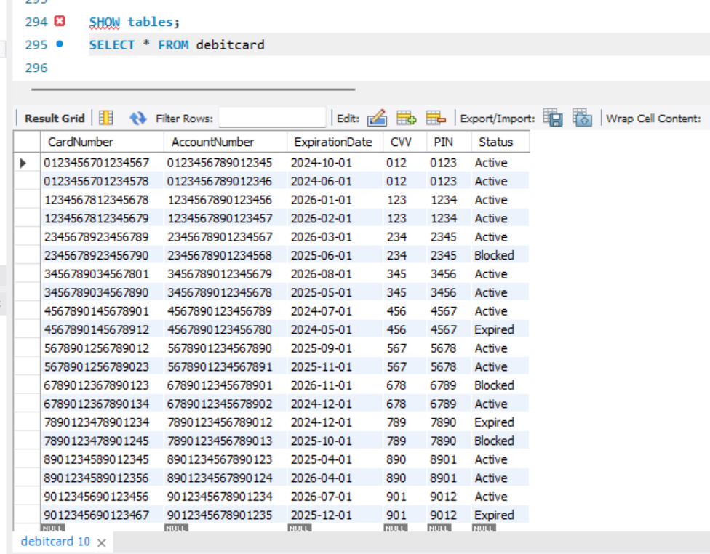

* **Employee Table:**

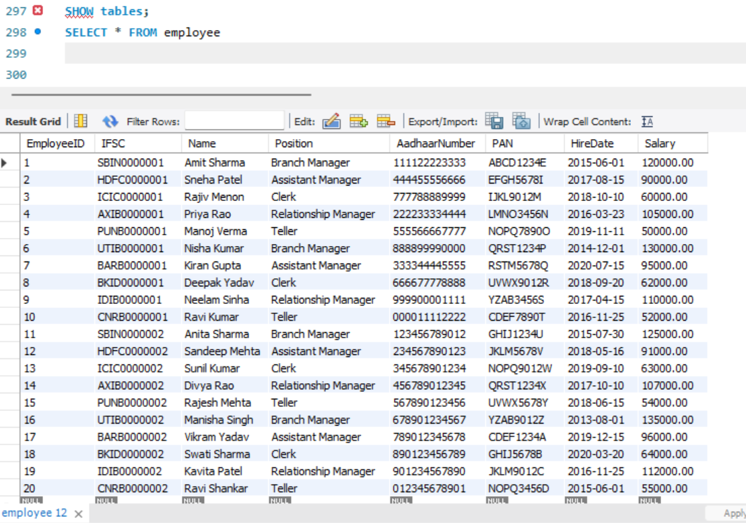

* **Fixed Deposit Table:**

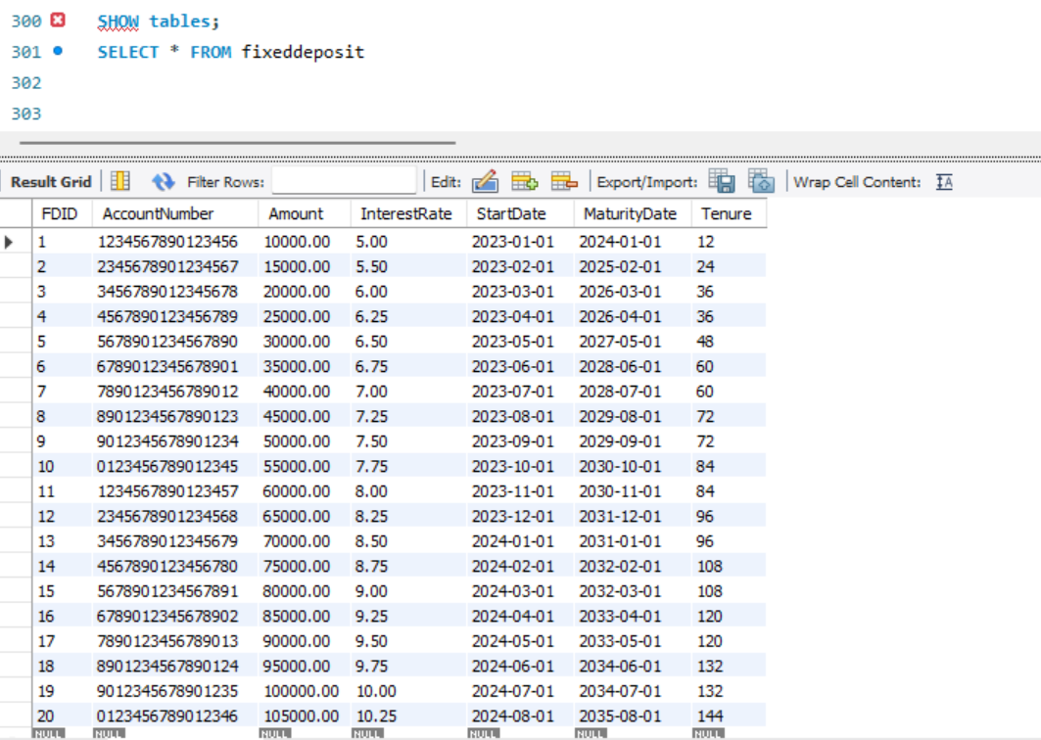

* **Loan Table:**

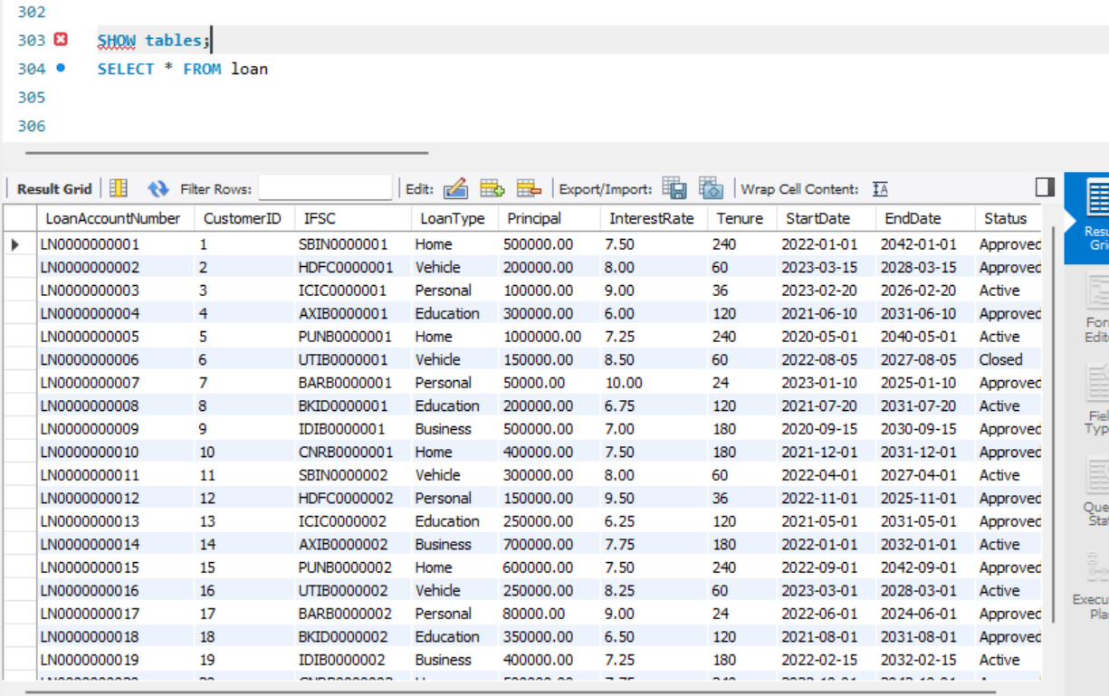

* **Transaction Table:**

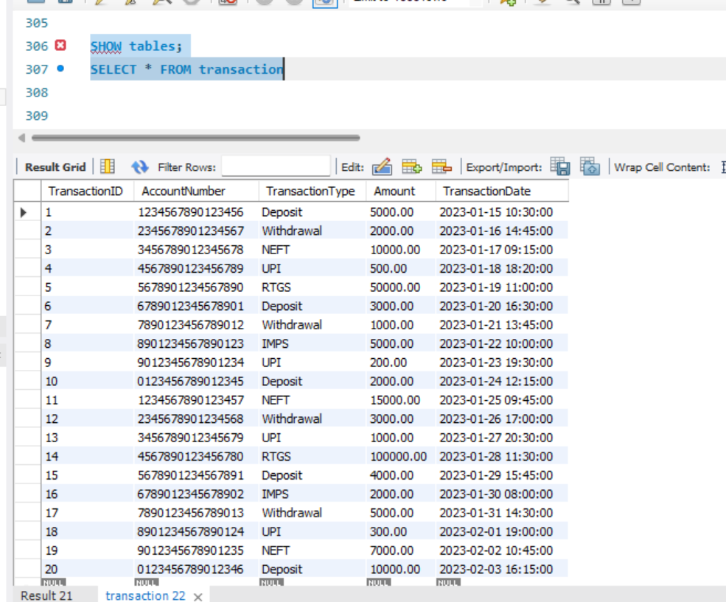

1. **Project 1e: Stress Testing of Database & Tables with CRUD Operations**

* **Create (Inserting data into the tables is done in following image)**

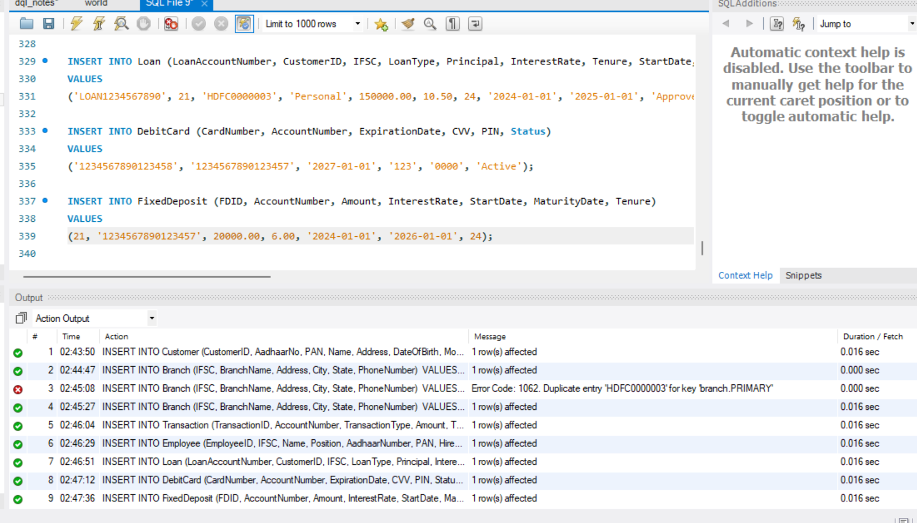

* **Read (Selecting of Data)**

1. **Selecting All Rows From Customer Table**

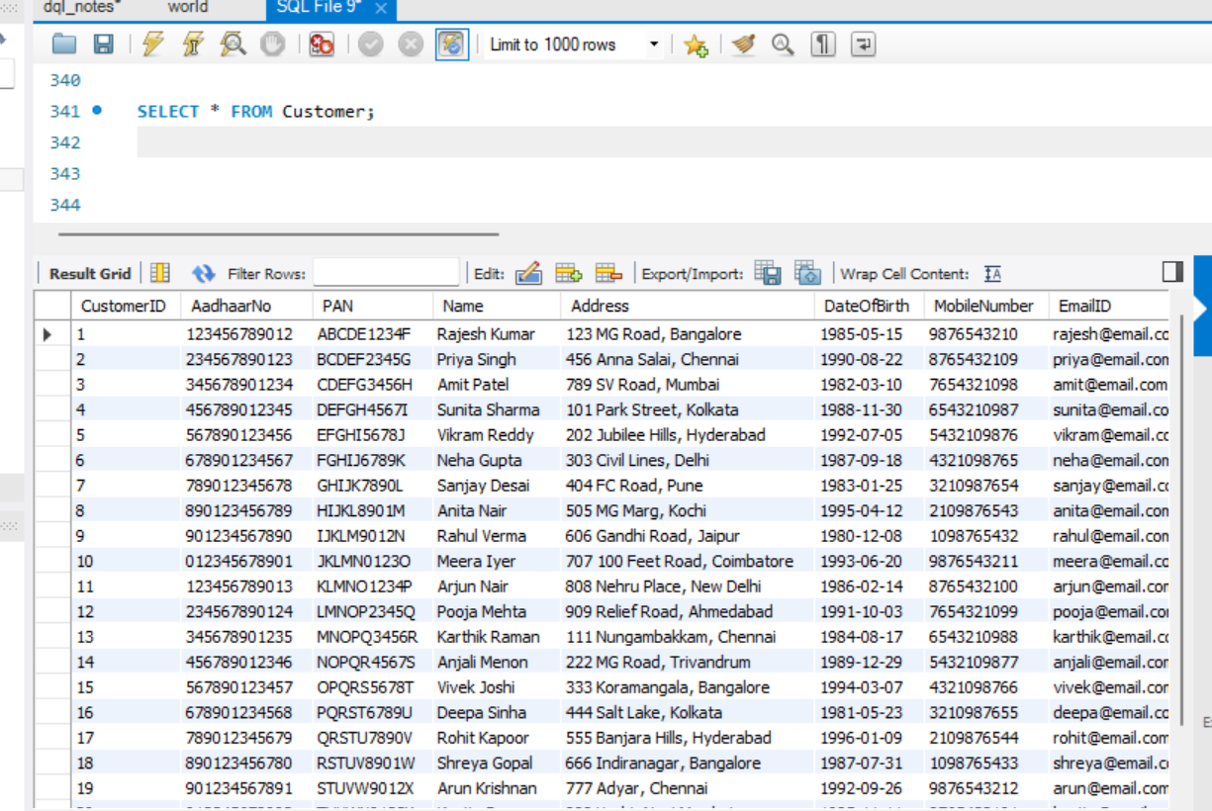

1. **Selecting Specific Columns from Branch Table**

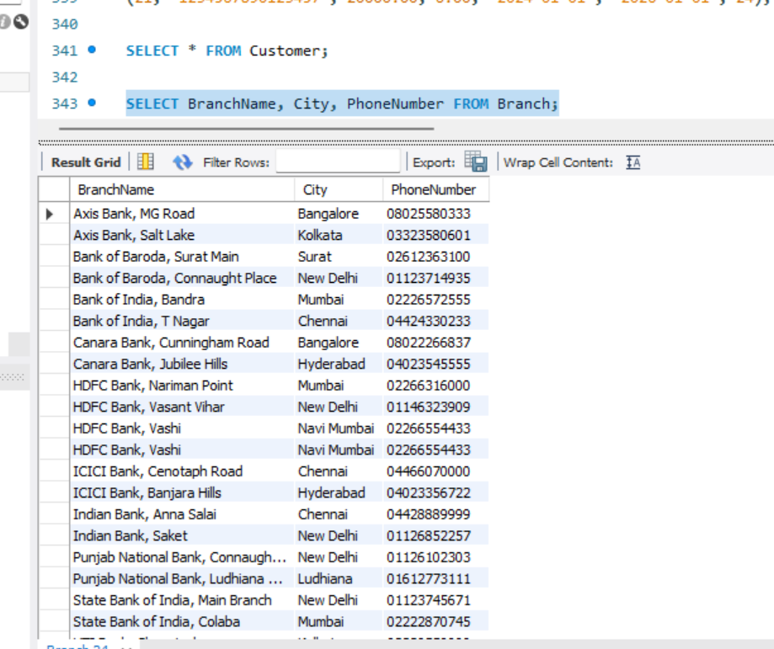

1. **Selecting Rows with Condition from Account Table**

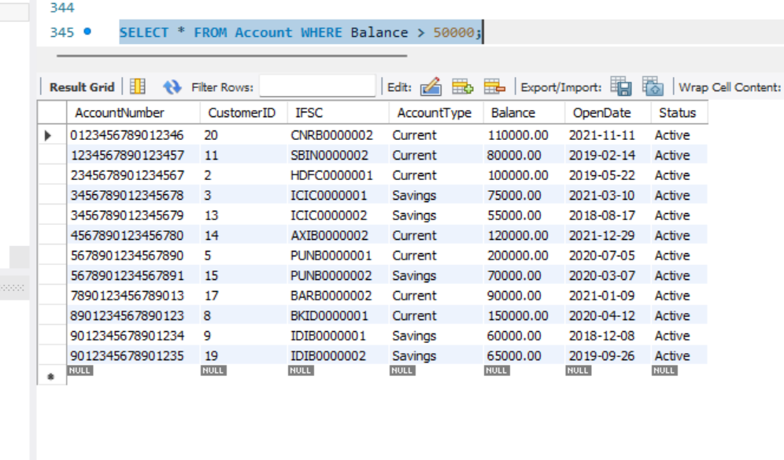

1. **Joining Tables and Selecting Data**

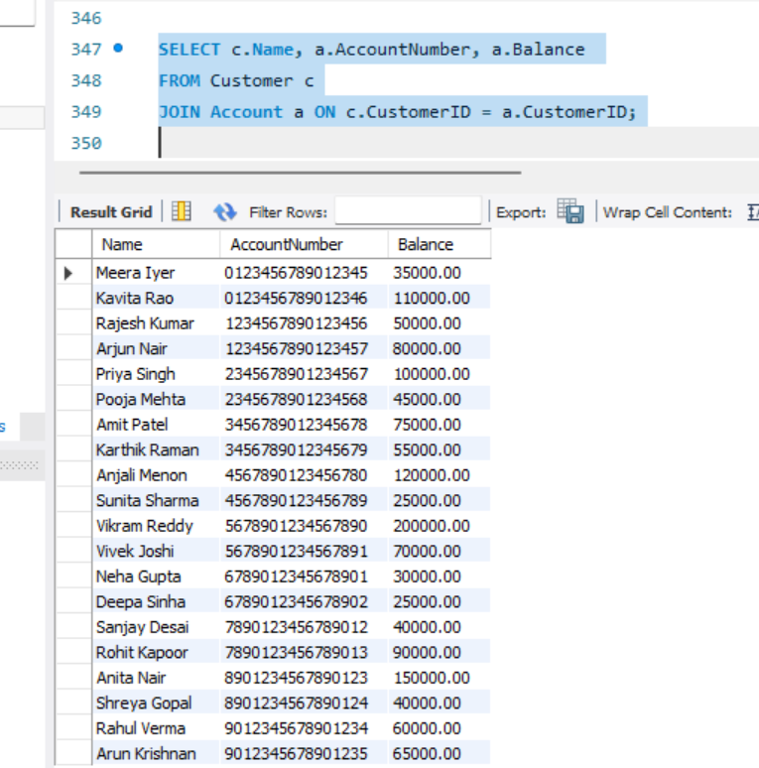

* **Update (Modifying Existing Data)**

1. **Updating Customer Data**

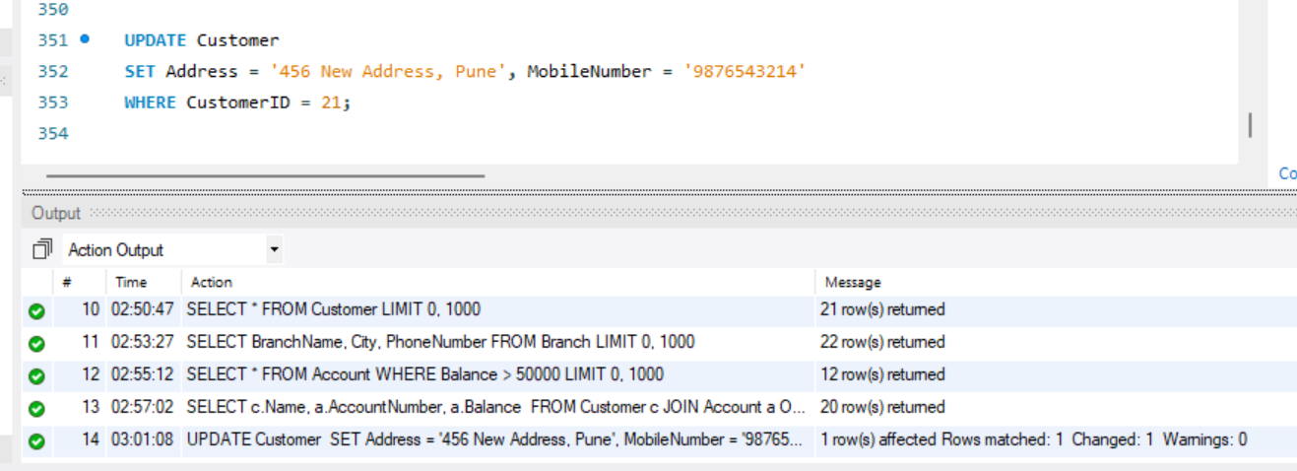

1. **Updating Account Balance**

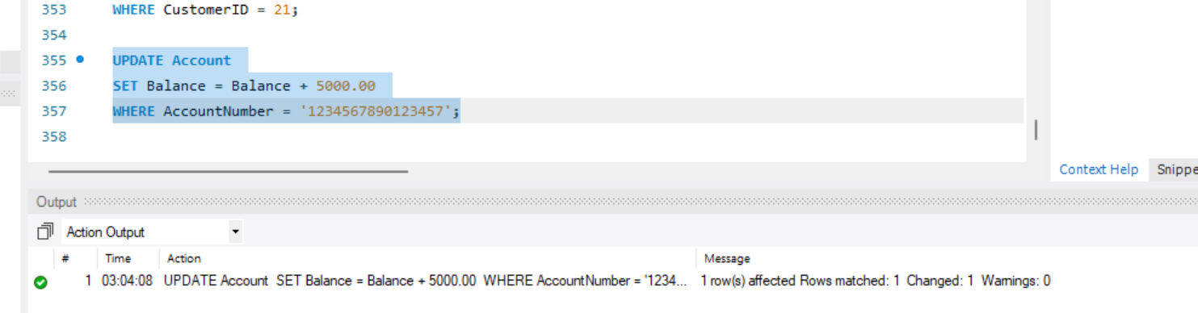

1. **Updating Loan Status**

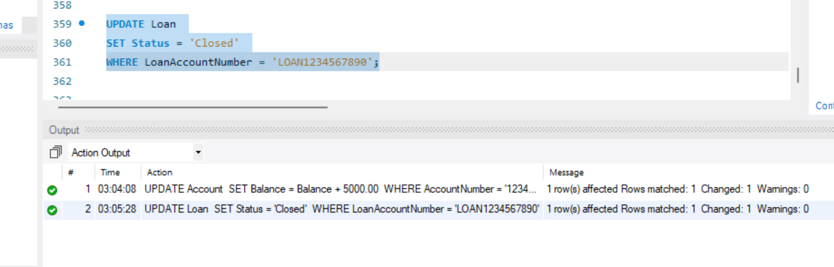

* **Delete (Removing Data)**

1. **Deleting a Record from Customer Table**

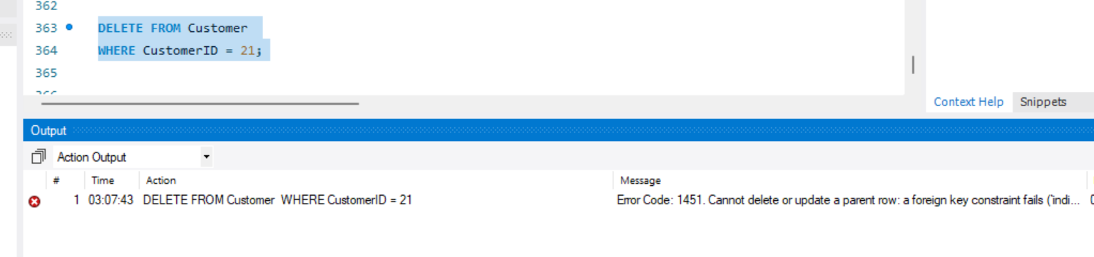

1. **Deleting Records from Account Table with Condition**

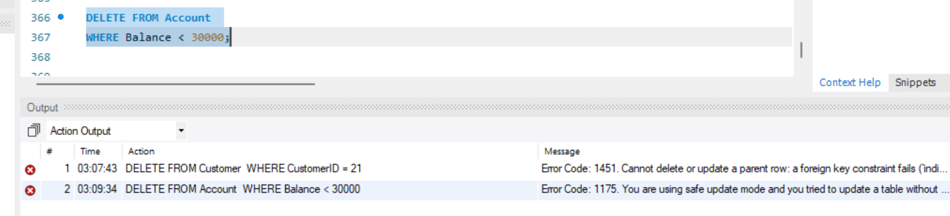

1. **Deleting Records from Transaction Table**

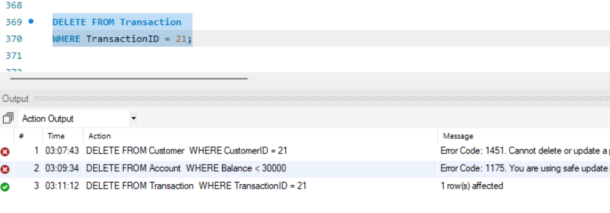**C. Project 1d: Report Normal Forms of the Tables**

**1. Customer Table**

**Schema:**

CREATE TABLE Customer (

CustomerID INT PRIMARY KEY,

AadhaarNo VARCHAR(12) UNIQUE,

PAN VARCHAR(10) UNIQUE,

Name VARCHAR(100),

Address VARCHAR(200),

DateOfBirth DATE,

MobileNumber VARCHAR(10),

EmailID VARCHAR(100)

);

**Normal Form Analysis:**

* **First Normal Form (1NF):**

- The table is in 1NF as all attributes contain atomic values and there are no repeating groups.

* **Second Normal Form (2NF):**

- The table is in 2NF since there is a single primary key (CustomerID) and all non-key attributes (AadhaarNo, PAN, Name, Address, DateOfBirth, MobileNumber, EmailID) are fully functionally dependent on the primary key.

- AadhaarNo and PAN are candidate keys as they are UNIQUE.

* **Third Normal Form (3NF):**

- The table is in 3NF because all non-key attributes are not only fully functionally dependent on the primary key but also there are no transitive dependencies. Each non-key attribute is directly dependent on CustomerID.

**2. Branch Table**

**Schema:**

CREATE TABLE Branch (

IFSC VARCHAR(11) PRIMARY KEY,

BranchName VARCHAR(100),

Address VARCHAR(200),

City VARCHAR(50),

State VARCHAR(50),

PhoneNumber VARCHAR(15)

);

**Normal Form Analysis:**

* **First Normal Form (1NF):**

- The table is in 1NF as it contains only atomic values.

* **Second Normal Form (2NF):**

- The table is in 2NF with IFSC as the primary key. All non-key attributes (BranchName, Address, City, State, PhoneNumber) are fully functionally dependent on IFSC.

* **Third Normal Form (3NF):**

- The table is in 3NF because there are no transitive dependencies. All attributes depend solely on the primary key IFSC.

- In a real-world scenario, the Address attribute might be further normalized into separate fields for street, city, state, and zip code.

**3. Account Table**

**Schema:**

CREATE TABLE Account (

AccountNumber VARCHAR(16) PRIMARY KEY,

CustomerID INT,

IFSC VARCHAR(11),

AccountType ENUM('Savings', 'Current', 'Fixed Deposit', 'Recurring Deposit'),

Balance DECIMAL(15,2),

OpenDate DATE,

Status ENUM('Active', 'Dormant', 'Closed'),

FOREIGN KEY (CustomerID) REFERENCES Customer(CustomerID),

FOREIGN KEY (IFSC) REFERENCES Branch(IFSC)

);

**Normal Form Analysis:**

* **First Normal Form (1NF):**

- The table is in 1NF with atomic values and no repeating groups.

* **Second Normal Form (2NF):**

- The table is in 2NF as AccountNumber is the primary key and all non-key attributes (CustomerID, IFSC, AccountType, Balance, OpenDate, Status) are fully functionally dependent on AccountNumber.

- CustomerID and IFSC are not part of the primary key, which is important for the 2NF analysis.

* **Third Normal Form (3NF):**

- The table is in 3NF because there are no transitive dependencies. All attributes are dependent only on the primary key AccountNumber.

**4. Transaction Table**

**Schema:**

CREATE TABLE Transaction (

TransactionID INT PRIMARY KEY,

AccountNumber VARCHAR(16),

TransactionType ENUM('Deposit', 'Withdrawal', 'NEFT', 'RTGS', 'UPI', 'IMPS'),

Amount DECIMAL(15,2),

TransactionDate DATETIME,

FOREIGN KEY (AccountNumber) REFERENCES Account(AccountNumber)

);

**Normal Form Analysis:**

* **First Normal Form (1NF):**

- The table is in 1NF with atomic values and no repeating groups.

* **Second Normal Form (2NF):**

- The table is in 2NF with TransactionID as the primary key. All non-key attributes (AccountNumber, TransactionType, Amount, TransactionDate) are fully functionally dependent on TransactionID.

- AccountNumber is not part of the primary key.

* **Third Normal Form (3NF):**

- The table is in 3NF as there are no transitive dependencies. All non-key attributes depend solely on the primary key TransactionID.

**5. Employee Table**

**Schema:**

CREATE TABLE Employee (

EmployeeID INT PRIMARY KEY,

IFSC VARCHAR(11),

Name VARCHAR(100),

Position VARCHAR(50),

AadhaarNumber VARCHAR(12) UNIQUE,

PAN VARCHAR(10) UNIQUE,

HireDate DATE,

Salary DECIMAL(10,2),

FOREIGN KEY (IFSC) REFERENCES Branch(IFSC)

);

**Normal Form Analysis:**

* **First Normal Form (1NF):**

- The table is in 1NF with atomic values and no repeating groups.

* **Second Normal Form (2NF):**

- The table is in 2NF with EmployeeID as the primary key. All non-key attributes (IFSC, Name, Position, AadhaarNumber, PAN, HireDate, Salary) are fully functionally dependent on EmployeeID.

-AadhaarNumber and PAN are candidate keys as they are UNIQUE.

* **Third Normal Form (3NF):**

- The table is in 3NF as there are no transitive dependencies. All attributes are dependent only on the primary key EmployeeID.

**6. Loan Table**

**Schema:**

CREATE TABLE Loan (

LoanAccountNumber VARCHAR(16) PRIMARY KEY,

CustomerID INT,

IFSC VARCHAR(11),

LoanType ENUM('Personal', 'Home', 'Vehicle', 'Education', 'Business'),

Principal DECIMAL(15,2),

InterestRate DECIMAL(5,2),

Tenure INT,

StartDate DATE,

EndDate DATE,

Status ENUM('Pending', 'Approved', 'Rejected', 'Active', 'Closed'),

FOREIGN KEY (CustomerID) REFERENCES Customer(CustomerID),

FOREIGN KEY (IFSC) REFERENCES Branch(IFSC)

);

**Normal Form Analysis:**

* **First Normal Form (1NF):**

- The table is in 1NF with atomic values and no repeating groups.

* **Second Normal Form (2NF):**

- The table is in 2NF with LoanAccountNumber as the primary key. All non-key attributes (CustomerID, IFSC, LoanType, Principal, InterestRate, Tenure, StartDate, EndDate, Status) are fully functionally dependent on LoanAccountNumber.

-CustomerID and IFSC are not part of the primary key, which is important for the 2NF analysis.

* **Third Normal Form (3NF):**

- The table is in 3NF as there are no transitive dependencies. All attributes depend solely on the primary key LoanAccountNumber.

**7. DebitCard Table**

**Schema:**

CREATE TABLE DebitCard (

CardNumber VARCHAR(16) PRIMARY KEY,

AccountNumber VARCHAR(16),

ExpirationDate DATE,

CVV VARCHAR(3),

PIN VARCHAR(4),

Status ENUM('Active', 'Blocked', 'Expired'),

FOREIGN KEY (AccountNumber) REFERENCES Account(AccountNumber)

);

**Normal Form Analysis:**

* **First Normal Form (1NF):**

- The table is in 1NF with atomic values and no repeating groups.

* **Second Normal Form (2NF):**

- The table is in 2NF with CardNumber as the primary key. All non-key attributes (AccountNumber, ExpirationDate, CVV, PIN, Status) are fully functionally dependent on CardNumber.

* **Third Normal Form (3NF):**

- The table is in 3NF as there are no transitive dependencies. All attributes depend solely on the primary key CardNumber.

**8. FixedDeposit Table**

**Schema:**

CREATE TABLE FixedDeposit (

FDID INT PRIMARY KEY,

AccountNumber VARCHAR(16),

Amount DECIMAL(15,2),

InterestRate DECIMAL(5,2),

StartDate DATE,

MaturityDate DATE,

Tenure INT,

FOREIGN KEY (AccountNumber) REFERENCES Account(AccountNumber)

);

**Normal Form Analysis:**

* **First Normal Form (1NF):**

- The table is in 1NF with atomic values and no repeating groups.

* **Second Normal Form (2NF):**

- The table is in 2NF with FDID as the primary key. All non-key attributes (AccountNumber, Amount, InterestRate, StartDate, MaturityDate, Tenure) are fully functionally dependent on FDID.

* **Third Normal Form (3NF):**

- The table is in 3NF as there are no transitive dependencies. All attributes depend solely on the primary key FDID.